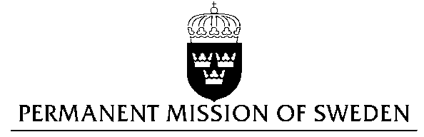
UN Human Rights Council

UPR 27th session

Statement by Sweden in the interactive dialogue on South Africa

Delivered by H.E. Ambassador Veronika Bard
Geneva, May 10, 2017 (speaking time 1 min 5 sec)

Mr President,

Sweden wishes to welcome the delegation and express our thanks for its presentation.

Sweden commends the Government of South Africa for accepting a majority of the recommendations from the 2nd UPR cycle and would like to give the following recommendations:

- to undertake continued and enhanced efforts to protect and provide redress to women suffering from violence and to continue raising awareness, through training and other means, in the judicial system, including the police, of the necessity to act against all cases of sexual and gender-based violence, including on the grounds of real or perceived sexual orientation, gender identity and expression,
- to take all necessary steps to address xenophobia through legislation and greater public/community awareness programs and promotion of tolerance and cultural diversity, and adopt a National Action Plan to combat Racism, Racial Discrimination, Xenophobia and Related Intolerance,
- to review the current text of the Protection of State Information Bill in order to remove any limitations on freedom of expression, including unwarranted persecution of whistle blowers,
- to safeguard that journalists and writers, especially those working for state owned media houses or public/state broadcasters, can work freely and without fear of reprisal for expressing critical opinions or covering subjects that the Government may find sensitive.

Sweden recognizes that South Africa has made significant advancement in the protection and promotion of women’s full enjoyment of human rights. The government has ratified the UN Convention on the Elimination of All Forms of Discrimination against Women. In 2007 it adopted a 365 national action plan to end gender-based violence and instituted a National Council Against Gender-Based Violence to coordinate and manage various gender-based violence initiatives.

Between 2006 and 2012, South Africa received the highest number of asylum seekers of any country in the world. The asylum laws of South Africa are progressive and migrants who apply for asylum have so far been able to live and work anywhere in the country until the state determines whether or not they qualify as a refugee. However, the challenges of unemployment, poverty and inequality have given rise to xenophobic tendencies. The country has seen recurring spates of violent attacks where immigrants are targeted, often resulting in fatalities.

In 2013 the Protection of State information Bill was passed by the National Assembly. The bill criminalises leaking, possessing and “receiving” information classified by the state. Individuals who contravene the law can be sentenced to up to 25 years in prison. Even though the bill has neither received Presidential assent, nor come into force, there still persists grave concern that the bill may be invoked to persecute activists, whistle-blowers and journalists who reveal classified information in the public interest.

Finally, Sweden wishes the Government of South Africa a successful UPR.

Thank you, Mr President.

